**Reply to comments on Clarkson et al. (2017) “Human Occupation of Northern Australia by 65,000 years ago”**

Chris Clarkson1, Richard G. Roberts2,3, Zenobia Jacobs2,3, Ben Marwick3,4, Richard Fullagar3, Lee J. Arnold5 and Quan Hua6

1School of Social Science, University of Queensland, Brisbane, Queensland 4072, Australia.

2Australian Research Council (ARC) Centre of Excellence for Australian Biodiversity and Heritage, University of Wollongong, Wollongong, New South Wales 2522, Australia.

3Centre for Archaeological Science, School of Earth and Environmental Sciences, University of Wollongong, Wollongong, New South Wales 2522, Australia.

4Department of Anthropology, University of Washington, Seattle, Washington 98195, USA.

5School of Physical Sciences, the Environment Institute and the Institute for Photonics and Advanced Sensing, University of Adelaide, Adelaide, South Australia 5005, Australia.

6Australian Nuclear Science and Technology Organisation, Lucas Heights, New South Wales 2234, Australia.

We thank the authors for their comments in the previous issue of *Australian Archaeology*. The 2012–2015 research at Madjedbebe offers a new and comprehensive look at the early occupation of Sahul and adds substantially to our knowledge of the timing of that event and the behaviour of the first people to enter the region. Establishing occupation of northern Australia by 65 ± 6 thousand years ago (ka, with the uncertainty expressed at 95.4% probability) pushes human presence in the Top End back beyond the earliest ages so far reported for other Australian sites by c. 5,000–15,000 years (Hamm et al. 2016; Roberts et al. 1994; Veth et al. 2017), thus raising interesting questions as to the latitudinal extent of continental occupation prior to 50 ka.

At Madjedbebe, a dense and diverse lithic assemblage, the oldest edge-ground tools in the world, the earliest seed grinding outside Africa, and an abundance of ground ochre in the lowest dense artefact band (termed Phase 2), all point to an innovative and expressive culture that had developed many iconic aspects of Aboriginal technology and economy by 65 ± 6 ka. The detailed documentation of dense pulses of artefacts (each containing different technologies and raw materials), intact site structures (such as hearths comprising diverse carbonised food remains), bands of refitting artefacts and no evidence of extensive bioturbation provides, in our view, the best evidence yet reported for multiple intact phases of occupation in Australia beginning c. 65 ka.

We take this opportunity to respond to queries raised in the previous issue of AA and attempt to clarify some key points to avoid misunderstandings. We respond below to four issues: 1) radiocarbon dating of the lowest hearth; 2) the distribution of artefacts in Phases 1 and 2; 3) the OSL chronology for Phase 2; and 4) the implications of our results for genetic analyses and archaeological signatures of human dispersal Out of Africa and into Sahul. We also correct a presentation error in Supplementary Table 15 of Clarkson et al. (2017).

1. Radiocarbon (14C) dating. Veth (2017) asks why charcoal from the lowest hearth (C1/43a) was not submitted for 14C dating. In fact, a sample of charcoal from C1/43a was submitted for 14C dating at ANSTO, but it did not survive chemical pre-treatment­ - as was the case for most of the other samples collected from depths below 1.5 m, due to the generally poor preservation of organic remains in tropical sandy sediments. This is well illustrated by the fact that 16 of 40 radiocarbon samples submitted did not survive chemical pre-treatment, with the number of samples dissolved increasing with depth (see Fig. 1 below). This poor preservation highlights the difficulties of developing reliable radiocarbon chronologies older than about 20 ka in environmental settings such as Madjedbebe, where organic remains are intensively weathered.

Detailed study of these ‘old’ charcoal pieces shows that their original morphological appearance (i.e., the physical structure) has been faithfully preserved. However, the original chemical composition has been altered and the elemental carbon required for radiocarbon dating has not been retained. The chemical alteration of charcoal, in a setting similar to Madjedbebe, has been reported previously in a radiocarbon dating study at the nearby site of Nauwalabila I (Bird et al. 2002). Extreme environmental conditions (e.g., high ambient temperature) can accelerate charcoal alteration and degradation (Braadbaart et al. 2009). Biotic processes may also alter charcoal chemistry in the environment via microbial mediation of degradation (Ascough et al. 2011; Bird et al. 2002; Cheng and Lehmann 2009). Similarly, charcoal that was produced at lower temperatures (<400 °C) or that has undergone incomplete thermal conversion is more susceptible to both chemical attack and post-depositional alteration (Ascough et al. 2011). Thus a combination of factors probably contributed to poor pre-treatment survival of charcoal found below 1.5m depth. We reiterate, however, that although sample survival during chemical pre-treatment was a pervasive problem at MJB, we were able to obtain a consistent series of radiocarbon ages that are in close agreement with OSL ages (Clarkson et al. 2017: Extended Data Fig. 8g).

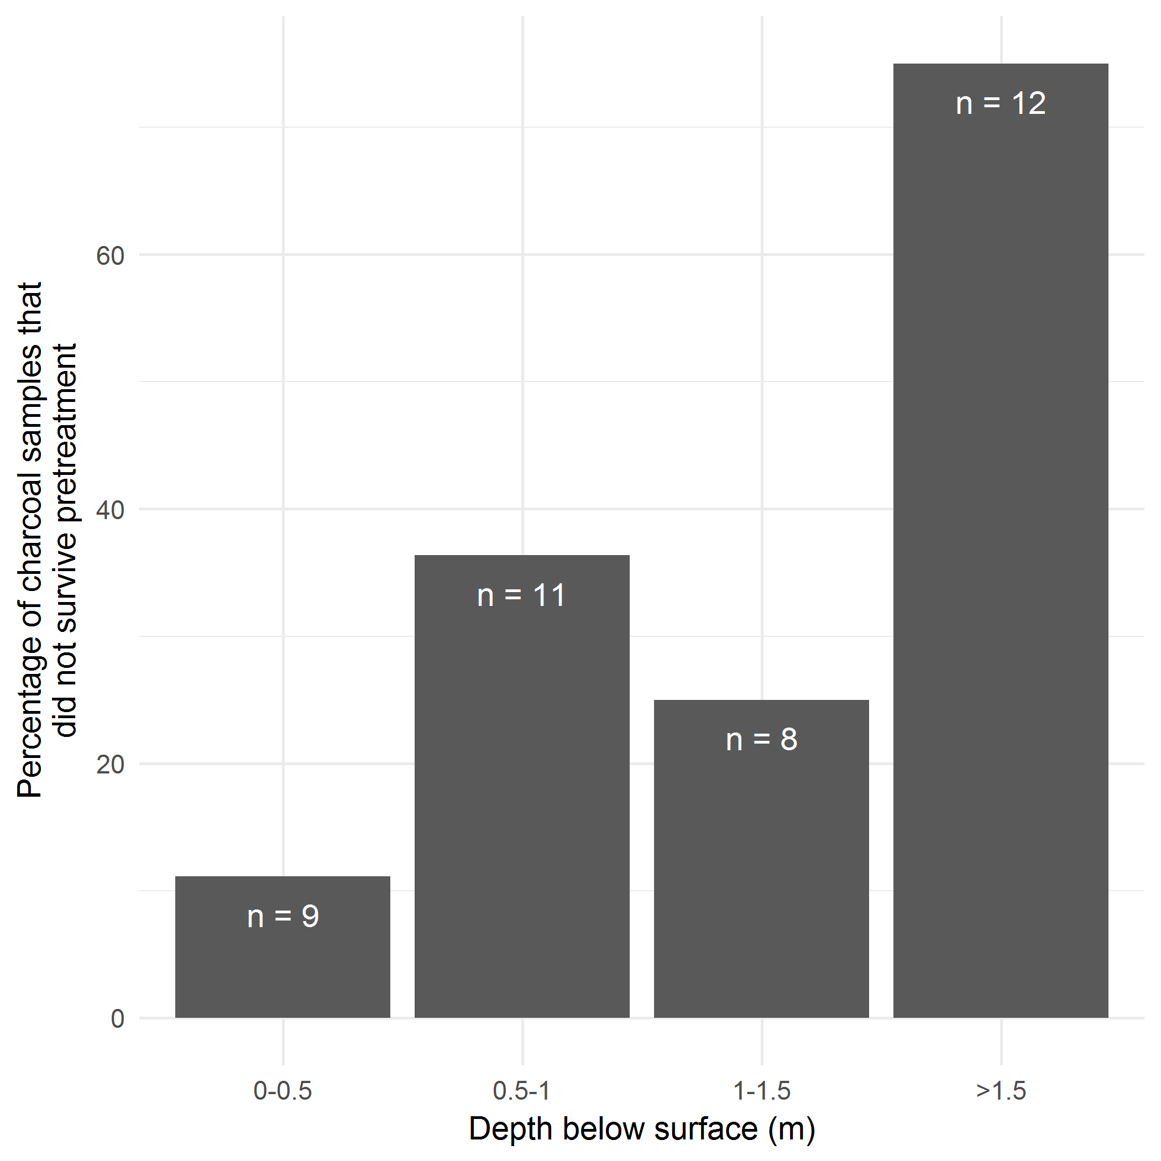

**Figure 1. Percentage of charcoal samples that did not survive chemical (ABA or ABOX) pre-treatment for 14C dating, plotted against sample depth. Note ‘n’ equals the number of samples submitted in each depth bracket.**

2. Distribution of artefacts in Phases 1 and 2. Individual artefacts excavated in 1989 (Roberts et al. 1990) could not be shown in Extended Data Figs 1a or 2a, because they were not piece plotted using a total station, like those collected in 2012 and 2015. We show in Figure 2 below, the artefact densities in squares B4–B6 and C4–C6 and the corresponding OSL ages for Phase 2, which is bracketed by depths of 2.15 and 2.60 m. The OSL age estimates for Phase 2 are consistent between the different squares: ages for square B4 range between c. 52 and 63 ka (2.16–2.45 m), for B5 between c. 63 and 65 ka (2.39–2.54 m) and C5 between c. 53 and 63 ka (2.20–2.50 m). In each square, a distinct pulse in artefact deposition is evident in Phase 2.

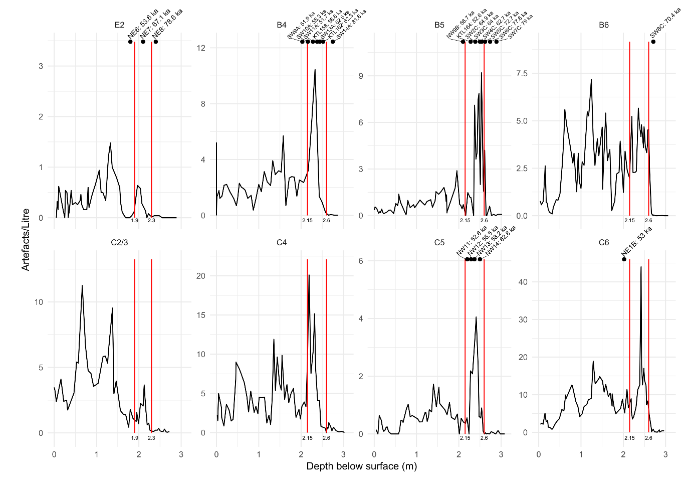

**Figure 2. Artefact densities for squares B4–B6 and C4–C6. Phase 2 (2.15–2.60 m depth in squares B4–B6 and C4–C6) is bracketed by the red lines and the OSL ages (in ka) are shown along the top of each panel.**

We used an objective measure – artefact frequency per litre (artefact density) of excavated sediment – together with assemblage composition (pulses in exotic silcrete, fine quartzite and chert, and the occurrence of thinning flakes) to define the Phase boundaries. The resulting lower boundary of Phase 2 (2.60 m depth in squares B4–B6 and C4–C6) is, therefore, a conservative estimate for the lowest *in situ* artefacts at Madjedbebe.

In response to Allen (2017), we note that the numbers of artefacts from square B6 attributed to the different Phases are listed incorrectly in Supplementary Table 15 of Clarkson et al. (2017). The correct numbers are listed in Table 1 below. The chi-square test results for this corrected table are similar to those reported in Clarkson et al. (2017), χ2 = 1118.5, df = 15, p-value < 2.2e-16, so the interpretation and conclusions therein are unaffected. The raw materials and technological composition of the Phase 1 and 2 assemblages are very similar, so we consider Phase 1 artefacts most likely represent the result of post-depositional displacement from Phase 2 deposits, although the possibility remains that they reflect an earlier occupation pulse. Ongoing analysis of the Phase 1 and 2 lithics will help resolve this issue.

**Table 1. Summary of stone artefact counts by Phase in square B6, for the four dominant raw materials only.**

|  |  |  |  |  |
| --- | --- | --- | --- | --- |
| **Phase** | **Chert** | **Quartz** | **Quartzite** | **Silcrete** |
| **1** | **1** | **28** | **36** | **3** |
| **2** | **69** | **1950** | **674** | **87** |
| **3** | **51** | **2551** | **178** | **11** |
| **4** | **59** | **3349** | **278** | **86** |
| **5** | **23** | **1009** | **13** | **2** |
| **6–7** | **10** | **1679** | **93** | **3** |

3. OSL chronology for Phase 2. Dortch and Malaspinas (2017) note that our ages for Madjedbebe are consistent with genetic approaches to dating the appearance of distinctively Australian populations, but they adopt a conservative view of the age of Phase 2 artefacts. They opt for the modelled end age of 53 ± 4 ka, rather than the modelled start age of 65 ± 6 ka; these two modelled estimates represent the minimum and maximum ages for the archaeological materials in Phase 2 and are based on a sequence of stratigraphically grouped ages that both overlay, span and underlie Phase 2. There is, therefore, no sound statistical basis for rejecting the latter as the most reliable age estimate for the start of Phase 2; this places initial settlement at between c. 71 and 59 ka ago at the 95.4% confidence level.

Although the c. 65 ka start age for Phase 2 has attracted the most attention, it should be borne in mind that this lowest dense band incorporates artefacts that were also deposited over the next 12 ka or so (see Fig. 2 above and Extended Data Figs 8c–f). We note that the captions for Extended Data Figs 8c and 8d should indicate squares B4 and B5 (not B5 and B6), respectively, and that the position of the SW-B and SW-C OSL sample sequence is laterally misplaced in Extended Data Fig. 8a by 30 cm, but is correctly plotted in Extended Data Fig. 1a. Hence, Phase 2 does not constitute a single snapshot in time, c. 65 ka ago, but rather an assemblage composed of more than 11,000 artefacts that have accumulated over twelve millennia. While the antiquity of the earliest Phase 2 artefacts precedes other discoveries made thus far elsewhere in Australia, the later Phase 2 artefacts coincide with a growing body of evidence for human occupation in other parts of the continent before 50 ka ago (Hamm et al. 2016; Veth et al. 2017).

4. Archaeological signatures of human dispersal and genetic analyses. The findings from Phase 2 at Madjedbebe have interesting implications for the Out of Africa story and the colonisation of Australia. The oldest assemblage suggests an innovative and highly expressive culture engaged in symbolic and technological activities, with long-distance (>80 km) maritime voyaging required to reach the shores of northwest Australia at 65 ka (Norman et al. 2018). The first occupants of Madjedbebe exploited the wide range of bush foods available in the region (including fruits, nuts, seeds and tubers) and had invested in technologies such as axes (for acquiring resources sequestered in trees) and grinding stones (for processing of labour-intensive foods and for extracting pigment powders). The presence of possible point technology (as seen from abundant thinning flakes and tips of retouched convergent flakes in Phase 2), as well as faceted discoidal cores, also harks beyond our region back to the Middle Stone Age (MSA) of Africa, the Levant, Arabia and India, where such technologies are the mainstay of modern humans living 50–100 ka (Clarkson 2014). It is tempting, therefore, to see the early Madjedbebe assemblage as a final stage in the chain of technological transmission, as early colonists blazed a trail eastward through Island Southeast Asia (ISEA) towards Australia. Unfortunately, none of the sites with modern human fossils dated ≥65 ka in ISEA and mainland Asia contain artefact assemblages with which to test this hypothesis of a MSA-like colonising toolkit (Liu et al. 2015; Westaway et al. 2017).

Finally, first occupation of Australia by c. 65 ka fits comfortably within the confidence intervals of 51–72 ka for the genetic split of Australians and Papua New Guineans from their Eurasian ancestors (Dortch and Malaspinas, 2017; Malaspinas et al. 2016) and with genetic and fossil evidence for the dispersal of modern humans into Asia at least 62–75 ka ago (Bae et al. 2018; Hershkovitz et al. 2018; Liu et al. 2015; Nielsen et al. 2017; Pagani et al. 2016; Rabett 2018; Rasmussen et al. 2011; Westaway et al. 2017). Several recent studies of the mitochondrial and nuclear DNA of recent and living Aboriginal Australians have yielded estimates of the time to the most recent common ancestor of Aboriginal Australians (Bergstrom et al. 2016; Malaspinas et al. 2016; Nagle et al. 2017; Tobler et al. 2017). The uncertainties of these genetic clocks associated with mutation rate and generation interval may be on the order of ± 30% at the 95.4% confidence interval (Fu *et al*., 2014; Mallick *et al*., 2016). If these uncertainties are taken into account, then all current genetic age estimates for the first Aboriginal Australians are consistent with an age of c. 65 ka for modern humans at Madjedbebe. The latter is also compatible with genetic estimates of the time of incorporation of Neanderthal genes into the modern human genome, and vice versa, which are constrained to no better than 37–86 ka (Sankararaman et al. 2012; Bae et al. 2017) and possibly much earlier (Prüfer et al. 2017).

The age of c. 65 ka for first occupation of Madjedbebe opens up several new lines of enquiry into the history of the human colonisation of Australia. The search is on for other sites that are similarly early, or even earlier, as well as sites that can close the c. 5,000–15,000 year gap between the oldest Phase 2 artefacts at Madjedbebe and the earliest artefacts reported elsewhere. Nauwalabila I (Roberts et al. 1994) remains a prospective candidate for further work, which is in progress. Likewise, we have begun an intensive program of exploration around Madjedbebe for sites with equivalent sequences and ages. These are important steps to assess the empirical reproducibility of our results from Madjedbebe. As Allen (2017) notes, reproducibility of results is a ‘fundamental cornerstone of the scientific method’, and one major commitment we have made to this is to openly share many of the raw data files and code from our analysis to enable others to inspect the details of our claims. Significant effort must now be invested in generating detailed and robust chronologies across northern Australia based on OSL and other techniques capable of extending beyond the 14C barrier, coupled with site formation and artefact provenance analyses. As Hiscock (2017) argues, only then will we be in a position to reflect on whether we have truly discovered the oldest sites in Australia.

**References**

Allen, J. 2017 Yes, Virginia, there is a Santa Claus; He just doesn’t bring presents to children who don’t believe in him. *Australian Archaeology*, *83*(3):163­165.

Ascough, P.L., M.I. Bird, S.M. Francis, B. Thornton, A.J. Midwood, A.C. Scott, D. Apperley 2011 Variability in oxidative degradation of charcoal: Influence of production conditions and environmental exposure. *Geochimica et Cosmochimica Acta* 75:2361–­2378.

Bae, C.J., K. Douka and M.D. Petraglia 2017 On the origin of modern humans: Asian perspectives. *Science* 358(6368), eaai9067.

Bergström, A., N. Nagle, Y. Chen, S. McCarthy, M.O. Pollard, Q. Ayub, S. Wilcox, L. Wilcox, R.A. van Oorschot, P. McAllister and L. Williams 2016 Deep roots for Aboriginal Australian Y chromosomes. *Current Biology* *26*(6):809–813.

Bird, M.I., C.S.M. Turney, L.K. Fifield, R. Jones, L.K. Ayliffe, A. Palmer, R. Cresswell and S. Robertson 2002 Radiocarbon analysis of the early archaeological site of Nauwalabila I, Arnhem Land, Australia: implications for sample suitability and stratigraphic integrity. *Quaternary Science Reviews* 21(8­9):1061–1075.

Braadbaart F., I. Poole and A.A. van Brussel 2009 Preservation potential of charcoal in alkaline environments: an experimental approach and implications for the archaeological record. *Journal of Archaeological Science* 36:1672­–1679.

Cheng, C.-H. and J. Lehmann 2009 Ageing of black carbon along a temperature gradient. *Chemosphere* 75(8):1021–­1027.

Clarkson, C. 2014. East of Eden: founder effects and the archaeological signature of modern human dispersal. In R. Dennell and M. Porr (eds) *Southern Asia, Australia and the Search for Human Origins.* pp.76–89. Cambridge University Press, Cambridge.

Clarkson, C., Z. Jacobs, B. Marwick, R. Fullagar, L. Wallis, M. Smith, R.G. Roberts, E. Hayes, K. Lowe, X. Carah, S.A. Florin, J. McNeil, D. Cox, L.J. Arnold, Q. Hua, J. Huntley, H.E.A. Brandl, T. Manne, A. Fairbairn, J. Shulmeister, L. Lyle, M. Salinas, M. Page, K. Connell, G. Park, K. Norman, T. Murphy and C. Pardoe 2017 Human occupation of Northern Australia by 65,000 years ago. *Nature* 547:306–310. (plus supplementary matter)

Dortch, J. and A.S. Malaspinas 2017 Madjedbebe and genomic histories of Aboriginal Australia. *Australian Archaeology* 83(3):174­–177.

Fu, Q., H. Li, P. Moorjani, F. Jay, S.M. Slepchenko, A.A. Bondarev, P.L.F. Johnson, A. Aximu-Petri, K. Prüfer, C. de Filippo, M. Meyer N.Zwyns, D.C. Salazar-García, V.H. Kuzmin, S.G. Keates, P.A. Kosintsev, D.I. Razhev, M.P. Richards, N.V. Peristov, M. Lachmann, K. Douka, T.F.G. Higham, M. Slatkin, J-J. Hublin, D. Reich, J. Kelso, T.B. Viola, T. Bence and S. Pääbo Genome sequence of a 45,000-year-old modern human from western Siberia. *Nature* 514(7523):445–449.

Hamm, G., P. Mitchell, L.J. Arnold, G.J. Prideaux, D. Questiaux, N.A. Spooner, V.A. Levchenko, E.C. Foley, T.H. Worthy, B. Stephenson and V. Coulthard 2016 Cultural innovation and megafauna interaction in the early settlement of arid Australia. *Nature* *539*(7628):280–283. (plus supplementary matter)

Hershkovitz, I., G.W. Weber, R. Quam, M. Duval, R. Grün, L. Kinsley, A. Ayalon, M. Bar-Matthews, H. Valladas, N. Mercier and J.L. Arsuaga 2018 The earliest modern humans outside Africa. *Science* *359*(6374):456–459.

Hiscock, P. 2017 Discovery curves, colonisation and Madjedbebe. *Australian Archaeology* 83(3):168–171.

Liu, W., M. Martinón-Torres, Y.-J. Cai, S. Xing, H.-W. Tong, S.W. Pei, M.J. Sier, X.-H. Wu, R.L. Edwards, H. Cheng, Y.-Y. Li, X.-X. Yang, J.M.B. de Castro and X.-J. Wu2015 The earliest unequivocally modern humans in southern China. Nature 526(7575):696–699.

Malaspinas, A., M. Westaway, C. Muller, V. Sousa, O. Lao, I. Alves, A. Bergström, G. Athanasiadis, J. Cheng, J. Crawford, T. Heupink, E. MacHoldt, S. Peischl, S. Rasmussen, S. Schiffels, S. Subramanian, J. Wright, A. Albrechtsen, C. Barbieri, I. Dupanloup, A. Eriksson, A. Margaryan, I. Moltke, I. Pugach, T. Korneliussen, I. Levkivskyi, J. Moreno-Mayar, S. Ni, F. Racimo, M. Sikora, Y. Xue, F. Aghakhanian, N. Brucato, S. Brunak, P. Campos, W. Clark, S. Ellingvåg, G. Fourmile, P. Gerbault, D. Injie, G. Koki, M. Leavesley, B. Logan, A. Lynch, E. Matisoo-Smith, P. McAllister, A. Mentzer, M. Metspalu, A. Migliano, L. Murgha, M. Phipps, W. Pomat, D. Reynolds, F. Ricaut, P. Siba, M. Thomas, T. Wales, C. Wall, S. Oppenheimer, C. Tyler-Smith, R. Durbin, J. Dortch, A. Manica, M. Schierup, R. Foley, M. Lahr, C. Bowern, J. Wall, T. Mailund, M. Stoneking, R. Nielsen, M. Sandhu, L. Excoffier, D. Lambert, E.. Willerslev 2016 A genomic history of Aboriginal Australia. *Nature* 538(7624):207–214. (plus supplementary matter)

Mallick, S., H. Li, M. Lipson, I. Mathieson, M. Gymrek, F. Racimo, M. Zhao, N. Chennagiri, S. Nordenfelt, A. Tandon, P. Skoglund, I. Lazaridis, S. Sankararaman, Q. Fu, N. Rohland, G. Renaud, Y. Erlich, T. Willems, C. Gallo, J.P. Spence, Y.S. Song,G. Poletti, N. Balloux, G. van Driem, P. de Knijff, I.G. Romero, A.R. Jha,.D.M. Behar, C.M. Bravi, C. Capelli, T. Hervig, A. Moreno-Estrada, O.L. Posukh, E. Balanovska, O. Balanovsky, S.Karachanak-Yankova, H. Sahakyan, D. Toncheva, L. Yepiskoposyan, C. Tyler-Smith, Y. Xue, M.S. Abdullah, A. Ruiz-Linares, C.M. Beall,.A. Di Rienzo, C. Jeong, E.B. Starikovskaya, E. Metspalu, J. Parik, R. Villems, B.M. Henn,.U. Hodoglugil, R. Mahley, A. Sajantila, G. Stamatoyannopoulos, J.T.S Wee, R. Khusainova, E. Khusnutdinova, S. Litvinov, G. Ayodo, D. Comas, M.F. Hammer, T. Kivisild, W. Klitz, C.A. Winkler, D. Labuda, M. Bamshad, L.B. Jorde, S.A. Tishkoff,.W.S. Watkins, M. Metspalu, S. Dryomov, R. Sukernik, L. Singh, K. Thangaraj, S. Pääbo, J. Kelso, N. Patterson and D. Reich 2016. The Simons genome diversity project: 300 genomes from 142 diverse populations. *Nature* *538*(7624):201–206. (plus supplementary matter)

Nagle, N., K.N. Ballantyne, M. Van Oven, C. Tyler-smith, Y. Xue, S. Wilcox, L. Wilcox, R. Turkalov, R.A.H. Van Oorschot, S. van Holst Pellekaan, T.G. Schurr, P. Mcallister, L. Williams, M. Kayser and R. J. Mitchell 2017 Mitochondrial DNA Diversity of Present-Day Aboriginal Australians and Implications for Human Evolution in Oceania.*Journal of Human Genetics* 62(3):343­–353.

Nielsen, R., J.M. Akey, M. Jakobsson, J.K. Pritchard, S. Tishkoff and E. Willerslev 2017 Tracing the peopling of the world through genomics. *Nature* 541(7637):302–310.

Norman, K., J. Inglis, C. Clarkson, J.T. Faith, J. Shulmeister and C. Harris 2018 An early colonisation pathway into northwest Australia 70–60,000 years ago. *Quaternary Science Reviews* 180:229–239.

Pagani, L., D.J. Lawson, E. Jagoda, A. Mörseburg, A. Eriksson, M. Mitt, F.Clemente, G. Hudjashov, M. DeGiorgio, L. Saag, J.D. Wall, A. Cardona, R. Mägi, M.A.W. Sayres, S. Kaewert, C. Inchley, C.L. Scheib, M. Järve, M. Karmin, G.S.Jacobs, T. Antao, F.M. Iliescu, A. Kushniarevich, Q. Ayub, C. Tyler-Smith, Y. Xue, B. Yunusbayev, K. Tambets, C.B. Mallick, L. Saag, E. Pocheshkhova, G.Andriadze, C. Muller, M.C. Westaway, D.M. Lambert, G. Zoraqi, S. Turdikulova, D. Dalimova, Z. Sabitov, G.N.N. Sultana, J. Lachance, S. Tishkoff, K. Momynaliev, J. Isakova, L.D. Damba, M. Gubina, P. Nymadawa, I. Evseeva, L. Atramentova, O. Utevska, F. Ricaut, N. Brucato, H. Sudoyo, T. Letellier, M.P. Cox, N.A.Barashkov, V. Škaro, L. Mulahasanovic, D. Primorac, H. Sahakyan, M. Mormina, C.A. Eichstaedt, D.V. Lichman, S. Abdullah, G. Chaubey, J.T.S. Wee, E. Mihailov, A. Karunas, S. Litvinov, R. Khusainova, N. Ekomasova, V. Akhmetova, I.Khidiyatova, D. Marjanović, L. Yepiskoposyan, D.M. Behar, E. Balanovska, A.Metspalu, M. Derenko, B. Malyarchuk, M. Voevoda, S.A. Fedorova, L.P.Osipova, M.M. Lahr, P. Gerbault, M. Leavesley, A.B. Migliano, M. Petraglia, O.Balanovsky, E.K. Khusnutdinova, E. Metspalu, M.G. Thomas, A. Manica, R.Nielsen, R. Villems, E. Willerslev, T. Kivisild and M. Metspalu 2016 Genomic analyses inform on migration events during the peopling of Eurasia. Nature 538(7624):238–242.

K. Prüfer, C. de Filippo, S. Grote, F. Mafessoni, P. Korlević, M. Hajdinjak, B. Vernot, L. Skov , P. Hsieh , S. Peyrégne , D. Reher , C. Hopfe , S. Nagel, T. Maricic , Q. Fu , C. Theunert, R. Rogers , P. Skoglund , M. Chintalapati , M.l Dannemann , B.J. Nelson , F. M. Key , P. Rudan, Ž. Kućan , I. Gušić, L. V. Golovanova , V.B. Doronichev , N. Patterson , D. Reich , E.E. Eichler , M. Slatkin , M.H. Schierup , A. Andrés , J. Kelso , M. Meyer and S. Pääbo 2017 A high-coverage Neandertal genome from Vindija Cave in Croatia. *Science* 358(6363)655–658.

Rabett, R.J., 2018 The success of failed Homo sapiens dispersals out of Africa and into Asia. *Nature Ecology & Evolution* 2:212–219.

Rasmussen, M., X., Guo, Y. Wang, K.E. Lohmueller, S. Rasmussen, A. Albrechtsen, L. Skotte, S. Lindgreen, M. Metspalu, T. Jombart and T. Kivisild 2011 An Aboriginal Australian genome reveals separate human dispersals into Asia. *Science* *334*(6052):94–98.

Roberts, R.G., R. Jones and M.A. Smith 1990 Thermoluminescence dating of a 50,000-year-old human occupation site in northern Australia. *Nature* *345*(6271):153–156.

Roberts, R.G., Jones, R., Spooner, N.A., Head, M.J., Murray, A.S. and Smith, M.A., 1994. The human colonisation of Australia: optical dates of 53,000 and 60,000 years bracket human arrival at Deaf Adder Gorge, Northern Territory. *Quaternary Science Reviews* 13(5):575–583.

Sankararaman, S., N. Patterson, H. Li, S. Pääbo and D. Reich 2012 The date of interbreeding between Neandertals and modern humans. *PLoS Genetics* 8, e1002947.

R. Tobler, A. Rohrlach, J. Soubrier, P. Bover, B. Llamas, J. Tuke, N. Bean, A.i Abdullah-Highfold, S. Agius, A. O’Donoghue, I. O’Loughlin, P. Sutton, F. Zilio, K. Walshe, A.N. Williams, C.S.M. Turney, M. Williams, S.M. Richards, R.J. Mitchell, E. Kowal, J.R. Stephen, L.Williams, W. Haak and A. Cooper 2017 Aboriginal mitogenomes reveal 50,000 years of regionalism in Australia. *Nature* 544(7649):180–184.

Veth, P. 2017 Breaking through the radiocarbon barrier: Madjedbebe and the new chronology for Aboriginal occupation of Australia. *Australian Archaeology*, *83*(3):165–167.

Veth, P., I. Ward, T. Manne, S. Ulm, K. Ditchfield, J. Dortch, F. Hook, F. Petchey, A. Hogg, D. Questiaux, and M. Demuro 2017 Early human occupation of a maritime desert, Barrow Island, North-West Australia. *Quaternary Science Reviews* 168:19–29.

Westaway, K.E., J. Louys, R.D. Awe, M.J. Morwood, G.J. Price, J.X. Zhao, M. Aubert, R. Joannes-Boyau, T.M. Smith, M.M. Skinner, T. Compton, R. M. Bailey, G. D. van den Bergh, J. de Vos, A. W. G. Pike, C. Stringer, E. W. Saptomo, Y. Rizal, J. Zaim, W. D. Santoso, A. Trihascaryo, L. Kinsley and B. Sulistyanto 2017 An early modern human presence in Sumatra 73,000–63,000 years ago. *Nature*, 548(7667):322–325.